15. Design TM using simulator to accept the input string anbn

AIM:TO Design TM using simulator to accept the input string anbn

DIAGRAM:

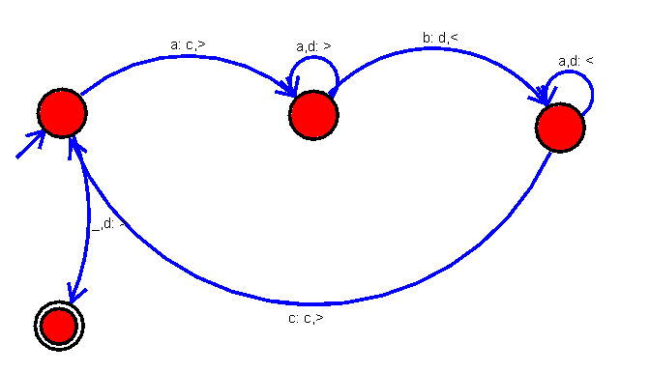

INPUT:

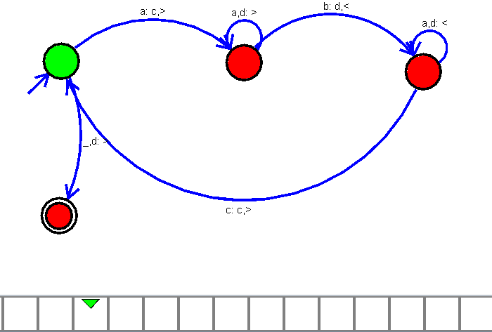

OUTPUT:

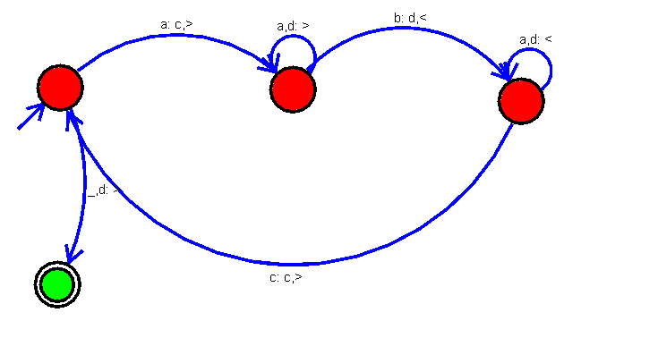

RESULT:

The implementation of Design TM using simulator to accept the input string anbn

successfully completed.